An Analysis of Microfinance in the United States
Experiences at the Community Financial Resource Center of Los Angeles
Amy Henning
Azusa Pacific University

Introduction to CFRC
The Community Financial Resource Center (CFRC) has been offering microloans, business education, and savings plans to low-income residents of South Los Angeles since 1993. The CFRC Capital Partners Micro-Lending Program is a comprehensive program that offers loans, business training and education, group support, and networking opportunities to self-employed business owners and entrepreneurs with limited access to working capital. The program utilizes a peer-lending model that requires participants to form lending groups. These groups enhance accountability and support for small business owners. The group model replaces the need for traditional capital and is based on the Grameen Bank, one of the first formal micro-lending institutions founded in Bangladesh.

Techniques of Participation
The emphasis of the Capital Partners Program is business training and networking as well as offering graduated loans to small business owners. The program will accept new start-ups, as long as they have a clear business plan. To qualify for a loan, participants must form lending groups of 3 to 8 entrepreneurs. This group becomes the means in which participants can then receive loans. To apply for the loan, each group member must present an application to the group who then approves or denies the loan, rather than a CFRC staff member. In this way, the entire group is socially responsible for the success of their group member. If a group member fails to repay a loan, the entire group cannot graduate to new loan levels until the amount is repaid. However, group members are not legally responsible for anyone else’s loans or for paying delinquent loans. The following chart illustrates the graduated loan design of the Capital Partners Program.

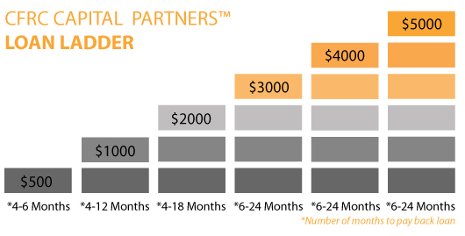

Loans must be repaid within the time frame at 10% interest, plus a monthly service fee of $3. At each loan level CFRC requires loan recipients to attend a 6-hour business-training course. Each level receives more complex training. If a participant continues with the program and graduates through all loan levels over the course of 2-5 years, they will have the basic tools to run a business as well as have rebuilt their credit in order to access traditional loans.

Microfinance in the United States
Microfinance is a fairly recent economic initiative worldwide, and even more so in the United States. One of the first adaptations of the microfinance model in the United States was the Good Faith Fund, started in 1988 in Arkansas by Bill Clinton (then governor) based on the Grameen Bank in Bangladesh, and funded by and modeled after the South Shore Bank, a community bank out of Chicago (Yunus & Jolis, 1998). Muhammad Yunus in his book, Banker to the Poor, is adamant in declaring that his microfinance model can succeed in the United States, citing the Good Faith Fund and the South Shore Bank as examples of success. Yet, after just two years of operation, the Good Faith Fund was receiving only 48% of repayments and demand for the program was low. Other programs in the United States have faced similar problems in maintaining both a wide outreach base and financial strength (Schreiner & Murdoch, 2001). According to an article in the Chicago Tribune, the South Shore Bank (renamed ShoreBank) declared bankruptcy in 2010. The loss of such an influential forerunner in the microfinance movement was a big hit for community economists (Yerak, 2010). I have been unable to find current information on the Good Faith Fund in Arkansas. It appears that a larger for-profit bank either acquired the organization or it too failed. These mixed results for microfinance have led Mark Schreiner and others to beg the question: What is it about the United States that makes microfinance difficult and how can it be altered for the U.S. context?

Comparative Analysis of U.S. vs. Foreign Microfinance
Microenterprise began as a Third World movement, the most notable success stories being the Grameen Bank in Bangladesh and BancoSol in Bolivia. As Ledgerwood (1999) points out in her Microfinance Handbook, it is incredibly important to know your context when starting a Microfinance Institution (MFI), and these grassroots organizations knew their cultural contexts very well. Yet, somehow when MFIs came to the West, the proven models were not working as expected. MFIs attempted to adapt to the cultural contexts of the West, but something was lost in translation. Mark Schreiner has done thorough analyses of MFIs throughout the world and he mentions contextual clues as to why MFIs in the Third World help millions of people with incredibly high repayment rates, while US organizations struggle to reach enough people and have low repayment rates.
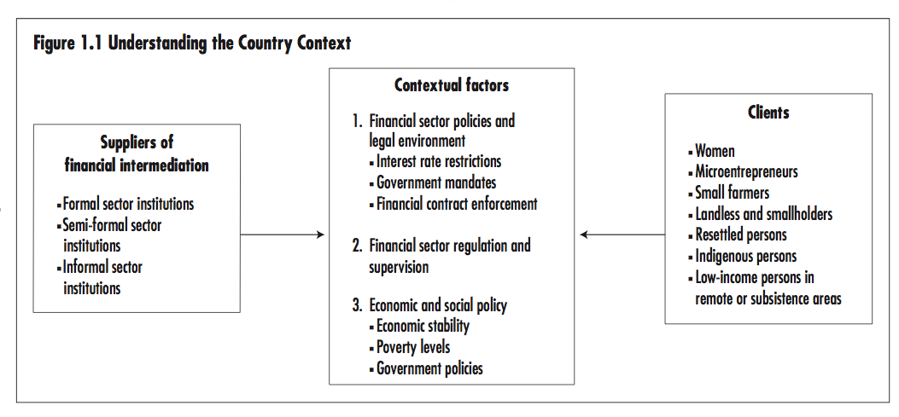
According to Schreiner and Murdoch (2001), there are two major contextual factors that affect the implementation of microfinance in the U.S. as compared to the Third World. The two factors are related to the viability of micro-entrepreneurship as a means of making a living. The first is that the structure of the U.S. economy presents far more hurdles for small business owners than the informal sector in most developing countries. And secondly, small businesses make up a much smaller portion of our national economy. This means that the demand for small businesses is low, the cost of operating is high, and the need for skill is much greater (Schreiner & Morduch, 2001).
“If company jobs were as scarce in America as they are in Africa—and self-employment were the only option—there is no question that we would be a nation of street vendors and small-scale entrepreneurs, especially if the government did not provide social safety nets.” (Greer & Smith, 2009)
This does not mean that microfinance cannot work in the United States, but as Ledgerwood pointed out and Schreiner affirms, MFIs in the U.S. must be able to understand these cultural factors and be able to innovate new ways of making microfinance work for the poor in the U.S. In contrast, there exists within the U.S. context a sub-context of immigrants from the developing world who in some ways create subcultures when they immigrate to the U.S. In my neighborhood in South Los Angeles, I have rarely seen an African American, Asian, or Caucasian person selling things in the street, but I have seen a number of Latin American people selling jewelry, flowers, bread, ice cream, tamales, and tacos. Some have licenses to operate street carts or food trucks, while others drive around in mini vans announcing their products with megaphones or walk shopping carts full of food down the streets. Some U.S. based MFIs, like Grameen America, have thrived by targeting this small (or in the case of Los Angeles, large) subcultural group of individuals in which the social capital is still high and the model used in the developing world is still directly applicable.
“The poor person who is well-suited for self-employment is probably also well-suited for wage-employment.” (Schreiner & Morduch, 2001)

An Introduction to Microfinance Delivery Models
MFIs in the Third World are built around the peer-lending or joint-liability groups. This model uses social capital to ensure repayment instead of traditional means of collateral. This method has been extremely effective overseas, but when replicated in the United States, was far less effective. The Community Financial Resource Center of Los Angeles uses a peer-lending model as described previously. However, the “social capital” element of this structure is lost because of the cultural context. This leaves CFRC with two choices: either find a means of increasing social capital or find a new means of collateral and risk assessment. Grameen America is an example of an organization in Los Angeles that chose to increase social capital by only working with Latina women. The Valley Economic Development Center went the other route and requires collateral.
In the developing world, group members usually live near each other and already know or know of each other. But in the U.S. people that live near each other probably do not know each other. This means that those interested in coming into the Capital Partners program must meet people, judge their ability to work with them on a single encounter, and form groups without really knowing each other. When I attended the Capital Partners Program orientation, some people were downright angry that they were being asked to work in groups and certainly indignant that they had to find their own groups. The rationale behind this is that there is absolutely no social capital in assigned groups because then the responsibility for group failure lies with the organization rather than group members, as it
would if they self-select. Schreiner and Murdoch propose “potential approaches include credit scoring (Schreiner, 2000b) and the use of landlord references, savings records and escrow accounts, proof of bill payments, and symbolic chattel mortgages.” (Schreiner & Morduch, 2001).

The following chart compares the Grameen Bank based model of micro-finance with the US Model of aid.
 | Grameen/International Model | CFRC/US Model
Purpose | Offer small loans to poor individuals who cannot otherwise access credit. | Offer comprehensive and innovative ways to build wealth for historically underserved residents and small business owners in South L.A. and across L.A. County.
Targeted Population | The desperately poor. Lower paid workers, landless, unemployed individuals, and those who are disadvantaged in the labor market (because of a language barrier or a handicap) | The working poor of LA ≤ 200% of poverty line  *Clients must have alternative source of income
Attitude toward Clients | Strengths Model: “The poor are very creative. They know how to earn a living and how to change their lives. All they need is opportunity.” (Yunus, p. 184) | Deficit Model: The poor lack the education and resources they need to run their own businesses and earn a living. They need training. This is congruent with U.S. culture
Approach | Staff finds clients in community. Trust is built and the poorest are helped. | Clients must come to agency
Lending | Members receive loans at about 30-45% of per capita income | Members receive loans at 5% or less of per capita income.
Repayment | Members repay on a weekly basis | Members repay on a monthly basis
Group Model | Uses the group model | Attempts to use the group model, some argue that Americans are too independent… Has worked in some communities, but is it better with immigrants?
Training | No training prior to receiving first loan. Why? Because everyone has a survival skill. Rather than teach new skills, loans help them use existing ones. Then group members teach each other. | 6 hours of basic business training prior to receiving each new loan.
Other | Large informal sector and smaller need for specific skills | Small informal sector, large legal barriers and start-up costs, greater need for specialized skill

Improving Microfinance Practice in the U.S.
Microfinance in the United States must start with a renewed vision for what small loans can do for poor families in our cities. Who are the poor? Are we seeking to help existing businesses succeed or do we want to see new businesses started? Are these businesses only supposed to supplement a family’s income or do we want to see them grow into businesses that employ community members and contribute to the local economy in a significant way? What tools do our entrepreneurs need to see their dreams realized? The answers to these questions will determine which structures will work most effectively.

As Ledgerwood states, “Organizations that do not define their objectives, and hence their target market, or that fail to design their products to meet the needs of this market often have difficulty managing their operations and staying focused.” (1999, p. 50). If CFRC’s goal is to reduce poverty, the target audience and services will look much different than if the goal is to create employment through small business. It is the difference between poverty alleviation programs and development programs (Schreiner & Morduch, 2001). With a clear vision, we can offer services within our scope of practice and do it well. Schreiner points out that the minimalist approach of offering only capital does not work in the United States because access to capital is not the biggest barrier to economic success. Credit cards, institutional banks, and other formal sector means of accessing capital are available, even to the poor.

Beyond Microfinance
Greer and Smith use the term “microfinance plus” to describe the potential of holistic services for the poor that can grow out of the microfinance movement. Growing a poor person’s income is good, but it is not all that can be done to help that person improve their life. There is a difference between merely increasing income and improving quality of life. Solomon (1992) believes that part of Grameen’s success is that they were always about more than just increasing income. They created their “Sixteen Decisions”, in which members pledge to do things like improve housing and grow vegetables. These are not related to their microloans, but are commitments to a better way of life. Micro-entrepreneurship results in a “release of human capital” and expands the use of the term entrepreneur beyond merely business, resulting in human betterment (Solomon, 1992). Because of this, MFIs working in the U.S. must be able to offer integrated services including enterprise development services and social services. The good thing about the U.S. social service system is that it is so vast each organization does not have to offer all services. Through increased community involvement, CFRC can partner more fully and formally with other organizations in Los Angeles to provide a full range of integrated services to clients. (Ledgerwood, 1999, 82).
Despite the challenges facing MFIs in the United States, there is significant potential for improving the lives of the poor, seeing micro-businesses succeed, and releasing human capital. U.S. based MFIs must be willing engage these challenges in innovative ways in order to understand and meet the needs of clients. CFRC can continue to help launch small business in Los Angeles by renewing their vision, adapting the programs to better fit the cultural context, and innovating new ways of meeting the needs of the community.

Resources

Greer, P., & Smith, P. B. (2009). The poor will be glad : joining the revolution to lift the world out of poverty. Grand Rapids, Mich.: Zondervan.

http://www.cfrcla.org/

Ledgerwood, Joanna, & Sustainable Banking with the Poor (Project). (1999). Microfinance handbook : an institutional and financial perspective. Washington, D.C.: World Bank.

Schreiner, M., & Morduch, J. (2001). Replicating microfinance in the United States: opportunities and challenges. Replicating Microfinance in the United States. Washington, DC: Fannie Mae Foundation.

Solomon, L. D. (1992). Microenterprise: Human reconstruction in America's inner cities. Harv. JL & Pub. Pol'y, 15, 191.

Yerak, B. (2010). Chicago's ShoreBank fails, is bought by investors - Chicago Tribune. Featured Articles From The Chicago Tribune. Retrieved July 15, 2013, from http://articles.chicagotribune.com/2010-08-20/business/ct-biz-0821-shorebank-20100820_1_fdic-assets-david-vitale

Yunus, Muhammad, & Jolis, Alan. (2007). Banker to the poor : micro-lending and the battle against world poverty. New York: PublicAffairs.

